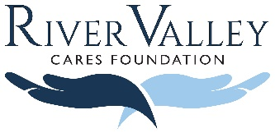
YOUR CONTRIBUTION
will make a difference in someone’s life.

I make this gift of $__________________ to River Valley Cares Foundation.

By making a tax-deductible donation to River Valley Cares Foundation, you not only ensure hospice patients and families are connected to the resources they need, you’re also paying tribute to the life of someone special to you. Every donation, no matter the size, is treated with the highest degree of respect.

Check #_________________ payable to River Valley Cares Foundation.
Please mail your tax-deductible donation to: River Valley Cares Foundation, 1990 McCulloch Blvd N., Ste 109, LHC, AZ 86403

Please tell us which River Valley Hospice location cared for your loved one?

YOUR INFORMATION
Name
Address
City/State/ZIP
Phone
Email

This gift is made in the name of
Please classify my gift as (select one): in memory in honor contribution

Please notify ________________________________________________________ that a donation has been made.
Address
City/State/ZIP
Phone
Email

River Valley Cares Foundation is an independent, 501 (C) (3) non-profit organization. All donations are tax deductible
The funds received by River Valley Cares Foundation are distributed back into local communities
YOUR GIFT GIVES COMPASSION TO OTHERS

